Respected Sir,
I am happy to share that our students paper, titled "Automated Classification of Diabetic Ulcers and Ordinary Wounds Using YOLOv7 for Medical Diagnosis" has been recognized with the 1st position in Scientific Abstract Presentation Presentation Award at the International Conference of Innovations in Biomechanics and Footwear Development: Shaping the Future of Movement, organized by Department of Physiotherapy, School of Allied Health Sciences, Galgotias University, in collaboration with the Centre of Excellence (CoE), Footwear Design & Development Institute (FDDI), Govt. of India on February 21-22, 2025 and the paper has also been accepted for publication in Springer, which is indexed in Scopus.
This remarkable achievement was made possible through the dedicated efforts of the following student team:
- Ayush Rathi (23BCE1509, B.Tech Computer Science)
- Saksham Anand (23BCE1529, B.Tech Computer Science)
- Abhiram Sharma (23BDS1093, B.Tech Computer Science with specialization in Data Science)
- Vasu Arya (23BCE1535, B.Tech Computer Science)
The paper was guided and supported by:
- Dr. Suganya R, Associate Professor (SCOPE)
Please find attached the certificate regarding the award.
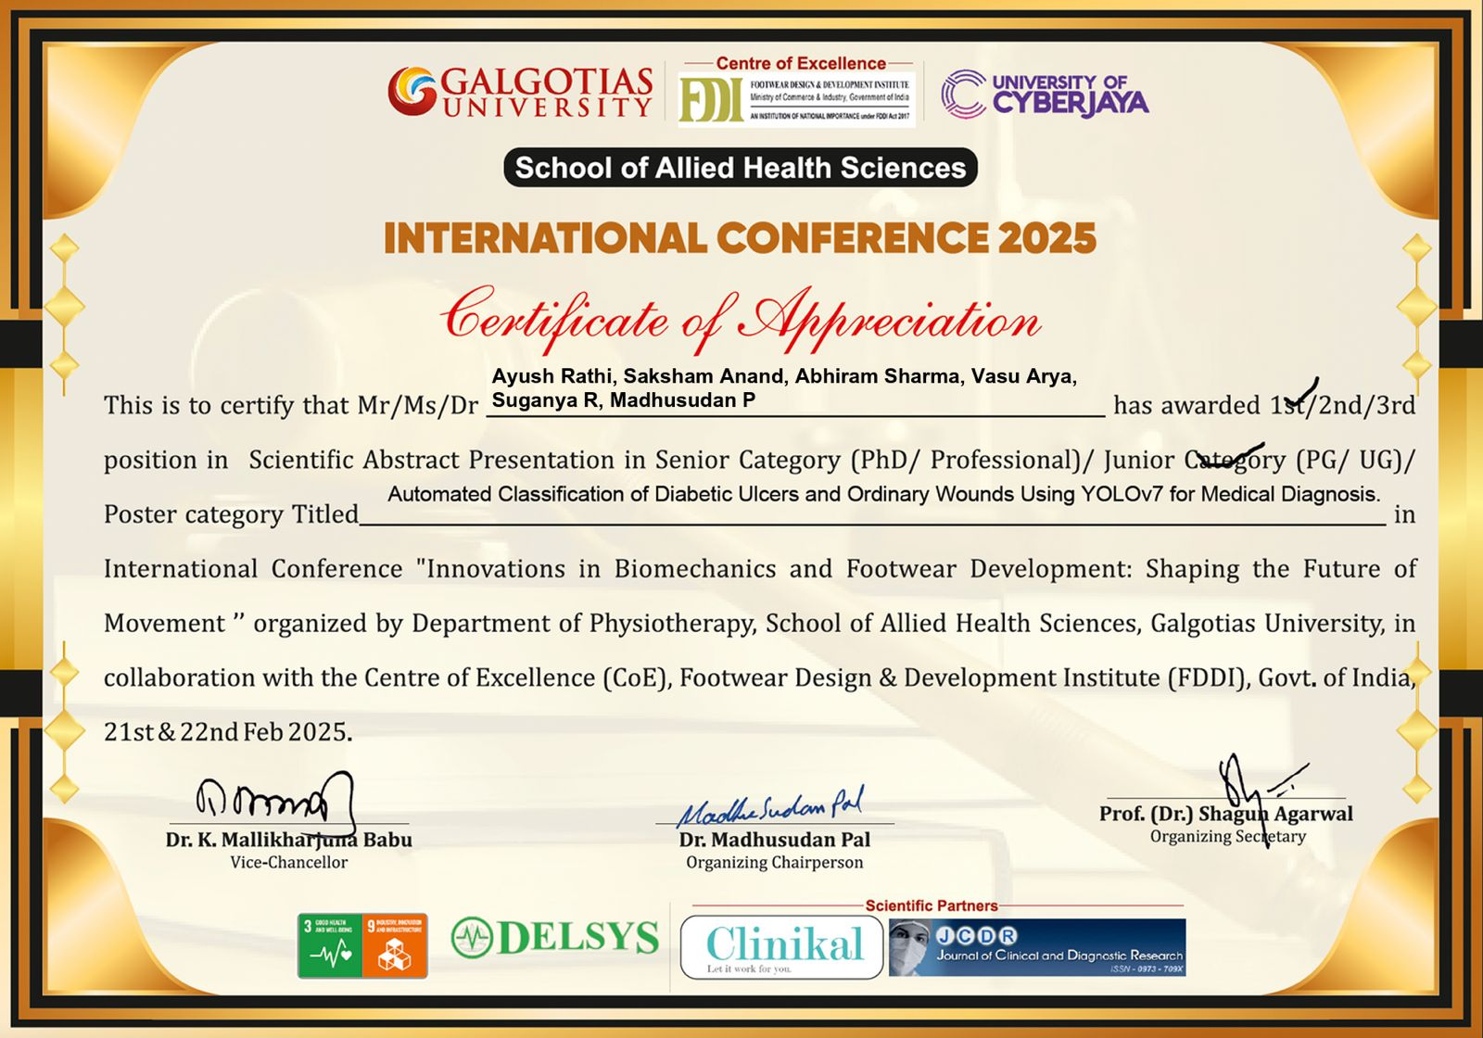
Best regards,
Dr. Suganya R
Associate Professor (SCOPE)
School of Computer Science and Engineering
VIT Chennai

